Module 8

Robertson, Rashai

Bellevue University, CSD325

Assignment 8.2

04/20/2025

Running program:

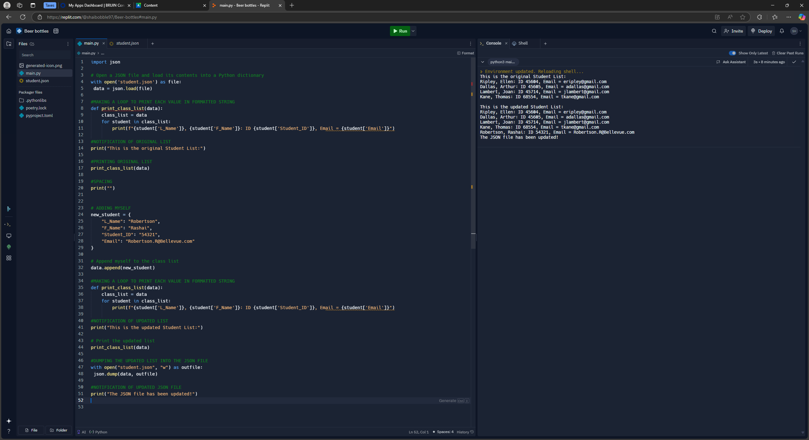

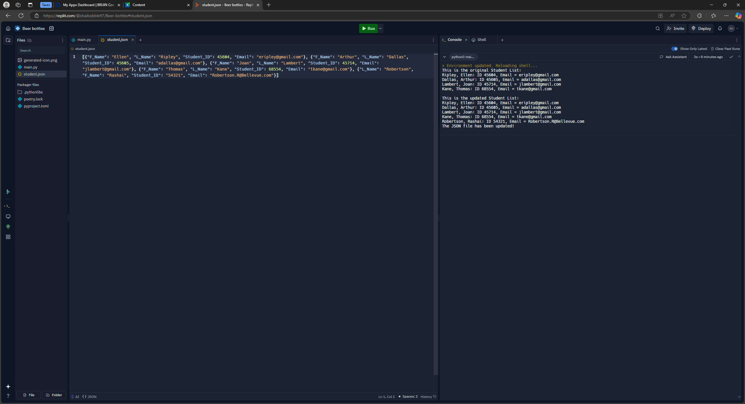

PyCharm version: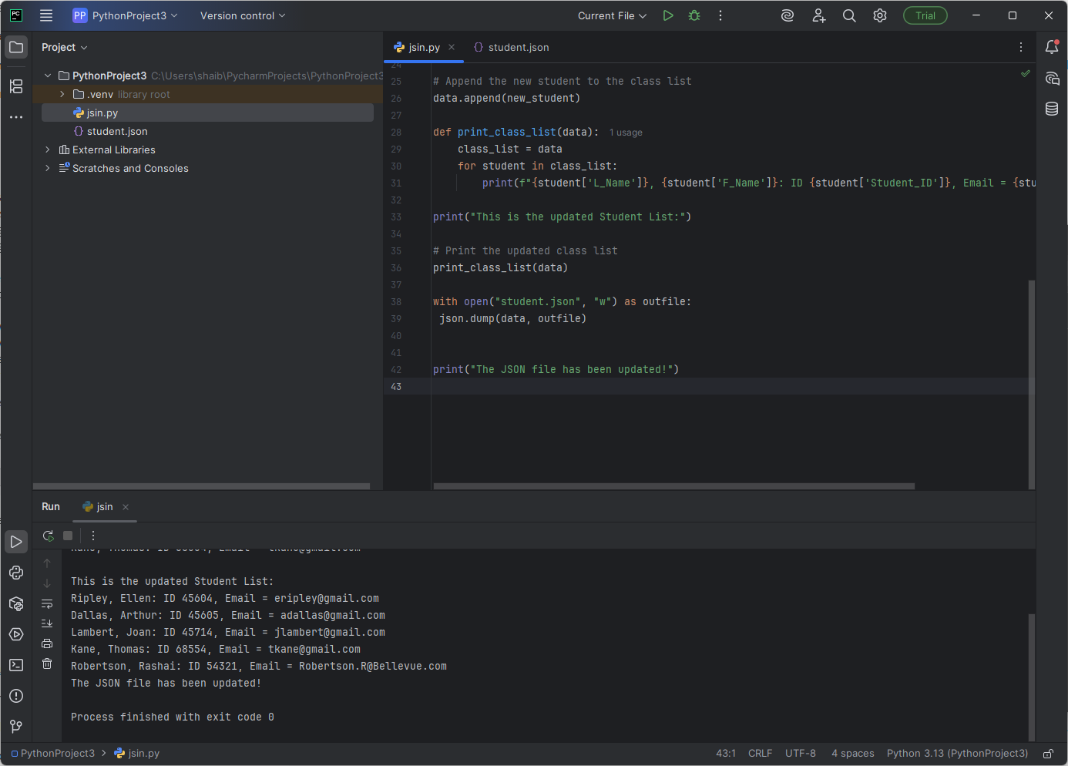

I never got a notification to save anything, but the file updated. What went wrong?

JSON:

[ {"F_Name": "Ellen", "L_Name": "Ripley", "Student_ID": 45604, "Email": "[eripley@gmail.com](mailto:eripley@gmail.com)"}, {"F_Name": "Arthur", "L_Name": "Dallas", "Student_ID": 45605, "Email": "[adallas@gmail.com](mailto:adallas@gmail.com)"}, {"F_Name": "Joan", "L_Name": "Lambert", "Student_ID": 45714, "Email": "[jlambert@gmail.com](mailto:jlambert@gmail.com)"}, {"F_Name": "Thomas", "L_Name": "Kane", "Student_ID": 68554, "Email": "[tkane@gmail.com](mailto:tkane@gmail.com)"}, {"L_Name": "Robertson", "F_Name": "Rashai", "Student_ID": "54321", "Email": [Robertson.R@Bellevue.com](mailto:Robertson.R@Bellevue.com)} ]